
To create primary key:

A_I creates a primary key for whatever you tick
this is where you add another column
if you want to add another column after making a table you can do it here:


to create foreign keys, in your link table, select the fields you want to turn into foreign keys and then select index



to link your 3 tables together you’ll need to first select the create relationship button then select the id from your table and connect it to the corresponding foreign key in your link to table (it must be in this order) like so don’t forget to set both to cascading in the box that comes up after making the link.
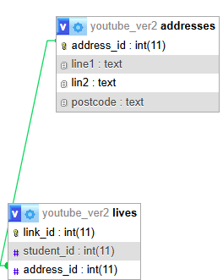

To create a new database you need to go to user accounts at the top of the homepage


once your in the new user section you need to change the username to the name of your new database and then create a password

